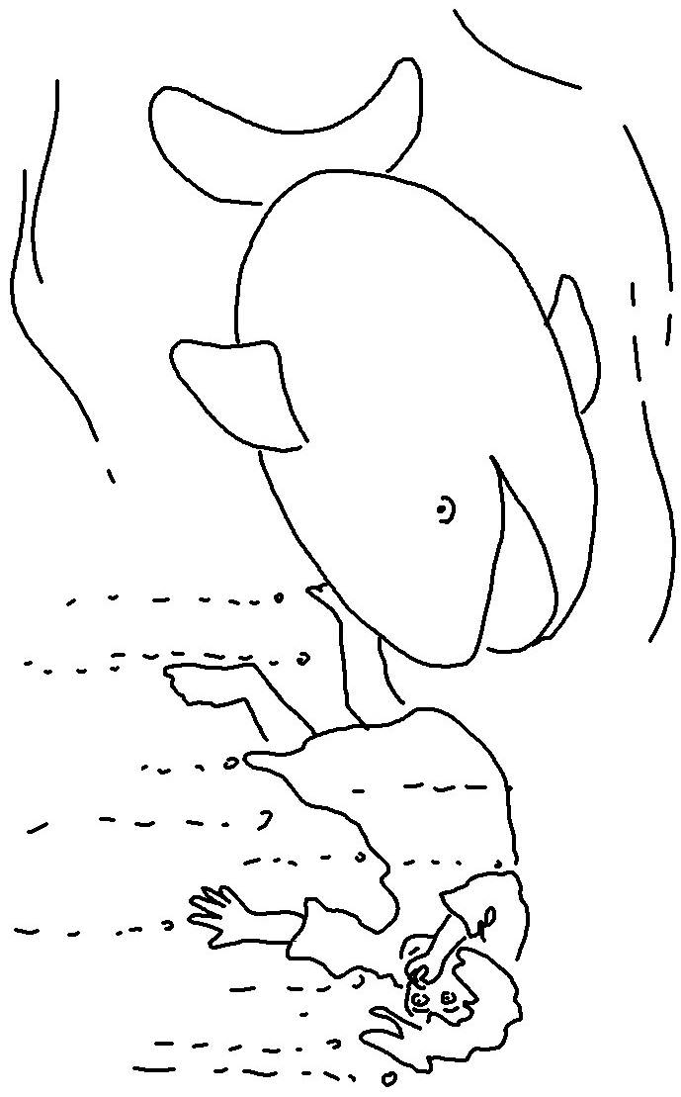

The Lord is slow to _ _ _ _ _ and filled with unfailing _ _ _ _, forgiving every kind of sin and rebellion.Numbers 14:18_{NLT}

